Experiment 2

Aim:

To redesign canteen menu at case of use and ease of functionality (grid and menu)

Procedure:

1.Choose any reference image and make it more effective using grid and menu.

2. Recreate the image. Don’t copy the image directly from the site.

3. Add more details for reference

4. Select the elements and change it by grid and menu.

Screenshot:

1. Before: 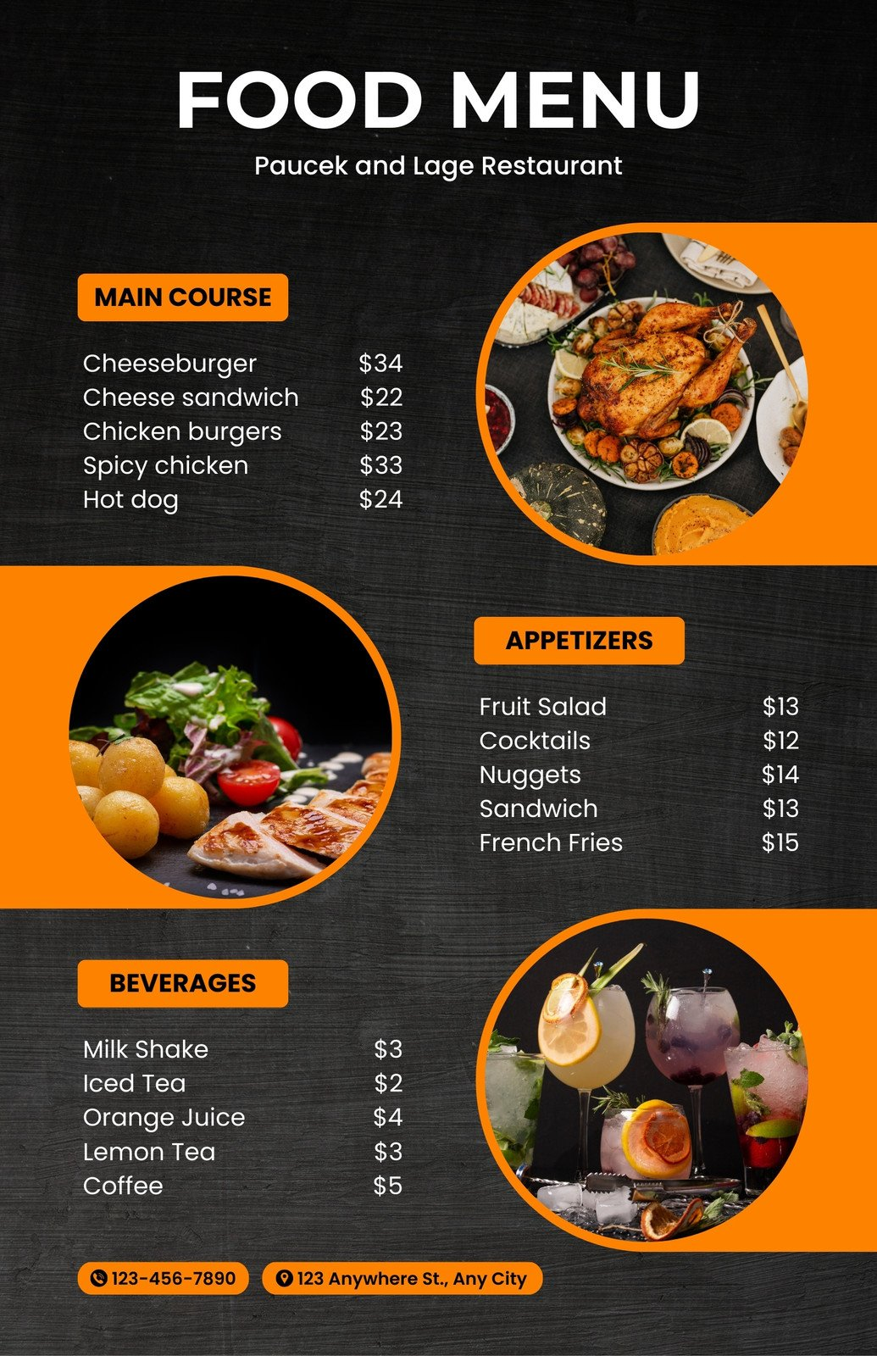
2. After:

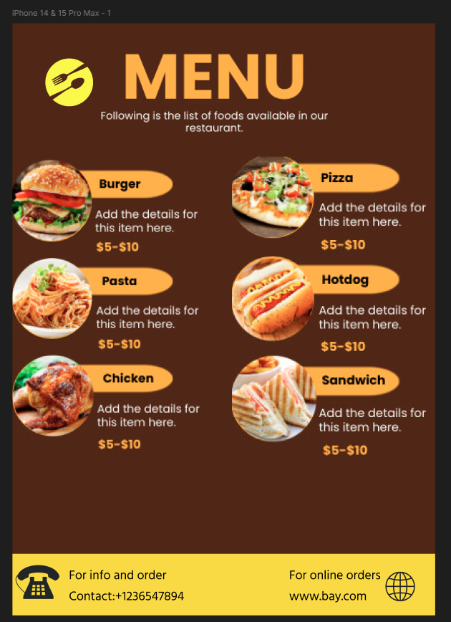

Result:  
Thus the canteen menu has been redesigned at case of use and ease of functionality.